TITLE OF ARTICLE

Author first name and surname (if there are multiple authors with different affiliations, use numbers in superscript¹)

Mentor(s): Full name, academic or research position (e.g., Dr Name Surname, Full Professor, Name Surname, Research Associate, Name Surname, Teaching Assistant)
¹Affiliation (e.g. University, Faculty, Department, Country)

Corresponding author: email@email.email

Summary presents the basic objective, material and method of the study, significant results and the conclusion. It should describe all essential facts of the paper. Keywords must be included. The summary should not be longer than 500 characters.

Key words: minimum 3; maximum 6 words.

INTRODUCTION

Introduction should outline the main reasons why the research was conducted; describe a brief review of literature consisting of refereed periodicals, journals and books and goal of the study.
The length of the paper, including tables, graphs, schemes, drawings and photographs, can be 6 pages at the maximum.

MATERIAL AND METHODS

Material used in the study, conducted experiments, conditions, procedures and analytical methods should be described in detail in this section. The whole methodology is only to be described if it is an original one; in other cases it is sufficient to cite the author of the method. Methods of statistical processing including the software used should also be listed in this section.

RESULTS AND DISCUSSION

The results obtained from the experiments including statistical analyses and any comments should be presented graphically or as tables in this section.

Table 1. Maximum and actual evapotranspiration, maximum and actual yield, evapotranspiration and irrigation water use efficiency
Year | ET_{m}  (mm) | ET_{a}  (mm) | Y_{m}  (t ha⁻¹) | Y_{a}  (t ha⁻¹) | IWUE  (kg m-3) | ET_{m}WUE  (kg m⁻³) | ET_{a}WUE  (kg m⁻³)
2005 | 505 | 502 | 95.765 | 87.983 | 3.7 | 19 | 18.1
2006 | 584 | 469 | 122.021 | 118.644 | 2.8 | 20.9 | 25.4
Average | 544 | 485 | 108.893 | 103.314 | 3.2 | 20 | 21.8

Legend:
ET_{m} = maximum evapotranspiration
ET_{a} = actual evapotranspiration
Y_{m} = maximum yield
Y_{a} = actual yield
IWUE = irrigation water use efficiency
ET_{m}WUE = water use efficiency based on maximum evapotranspiration
ET_{a}WUE = water use efficiency based on actual evapotranspiration

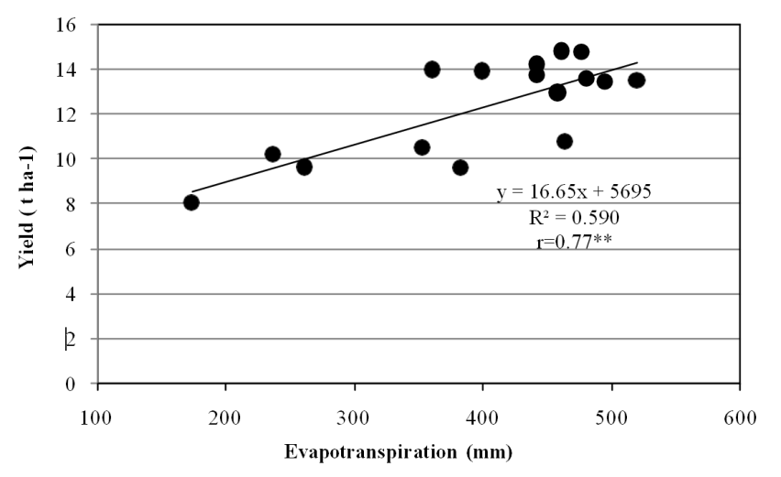
Fig. 1. Relationship between grain yield (Y) and seasonal crop water use (ET) of maize

Equations:
Insert all equations using Word Equation Editor (Insert → Equation).
Do not use images or screenshots for equations.
Display equations centered on a separate line; number them right-aligned if needed: (1).
Define all symbols immediately below the equation or in the text.
Example:
$$IWUE = \frac{Yi – Yd}{Ii}$$
Where:
IWUE = irrigation water use efficiency
Y_{i} = the yield (t ha⁻¹)
Y_{d} = the yield (t ha⁻¹)
I_{i} = the amount of irrigation water applied (mm)

CONCLUSIONS

Conclusions should be based on the results obtained in the study.

REFERENCES

PEJIĆ, B., GVOZDENOVIĆ-VARGA, J., VASIĆ, M., MILIĆ, S. (2009): Water balance, bioclimatic method as a base of rational irrigation regime of onion. Proc. of IVth Balkan symposium on vegetables and potatoes, 9-12 September, Plovdiv, Bulgaria, Acta Hort., 2: 355- 360.
PAYERO, J.O., MELVIN, S.R. IRMAK, S., TARKALSON, D. (2006): Yield response of corn to deficit irrigation in a semiarid climate. Agric. Water Manage. 84: 101-112.
STATISTICAL YEARBOOK, 2007. Online statistical database of the Serbia Republic. Available at: http://webrzs.stat.gov.rs
VUČIĆ, N. (1976): Irrigation of agricultural crops. Faculty of Agriculture Novi Sad, 187p.

